|  |  |
| --- | --- |
| **Project – External Document** |  |
| <COMP6681 | COMP6681001>  <Web Programming> |
| [Odd] Semester Year 2022/2023 |

* Project Title

MaiBoutique

* Introduction

Project building an E-commerce website using Laravel 8

* Report / Documentation

Login Information:  
Admin Account:   
Email = [admin@gmail.com](mailto:admin@gmail.com)  
Pass = admin  
Member Account:  
Email = [member@gmail.com](mailto:member@gmail.com)  
Pass = member  
  
Additional Notes:  
- Please run php artisan storage:link before migrating and seeding processes.

1. Views  
     
   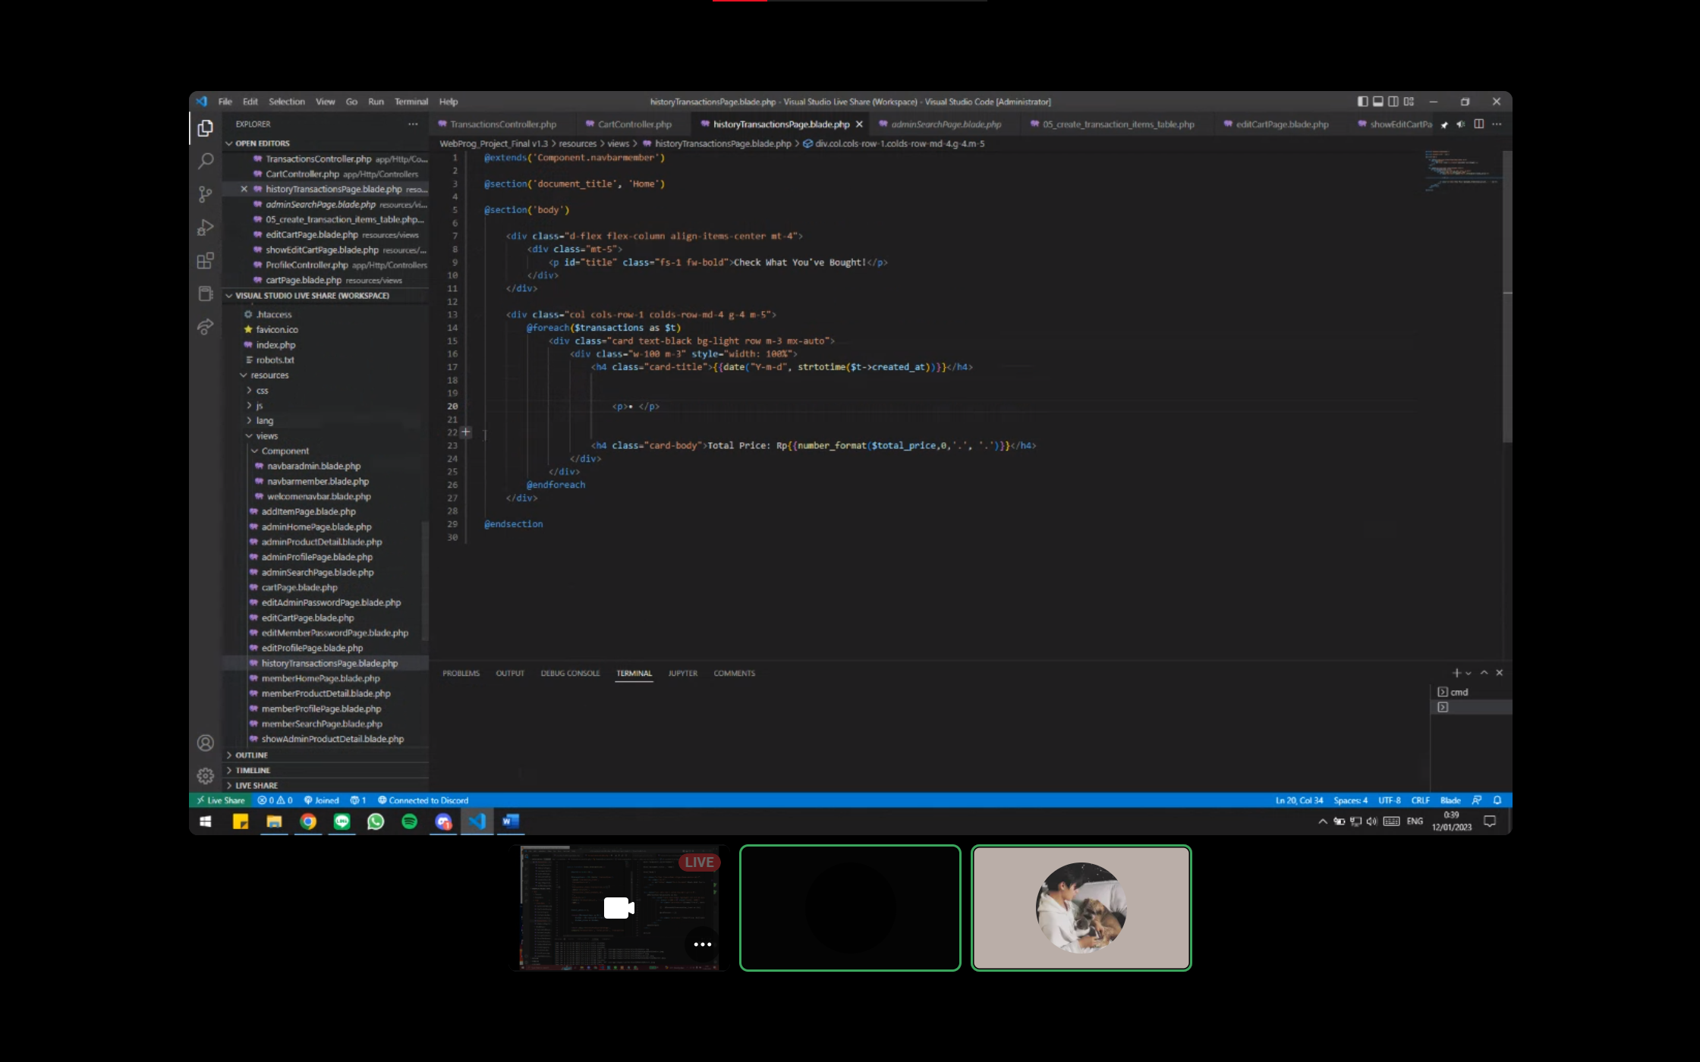
2. Controller  
   A screenshot of a computer

   Description automatically generated with medium confidence
3. Middleware  
   A screenshot of a computer

   Description automatically generated with medium confidence
4. Migrations   
   A screenshot of a computer

   Description automatically generated with medium confidence
5. Seeding

* Reference
* Bluejack
* Pinterest
* getbootstrap.com
* Group Member
* <2440107771> – <Linggar Tembus Nusantara>
* <2440030323> – <Enrico Fernandez>